Weather Trends

Analysis of Temperature Trends Globally and in the City of Phoenix

Steps Taken to complete the analysis:

- Using SQL, I found my city (Phoenix) in the city_data table using the following query (SELECT * FROM city_data WHERE city = 'Phoenix’;)
- I then grabbed the necessary data by only selecting the year and avg_temp fields (SELECT year, avg_temp FROM city_data WHERE city = 'Phoenix’;)
- I did a similar query for global data (SELECT * FROM global_data;)
- I noticed Phoenix data begins at year 1835 while global data begins at 1750 so I adjusted the global data query to match the city dataset (SELECT * FROM global_data WHERE year > 1834;)
- I then installed Anaconda and used Spyder to help plot the data with Python
- I imported the Python libraries pandas and matplotlib.pyplot to help read the CSV files and plot the graph
- I used pandas to read the CSV files and then do the simple moving average calculations for 10 years
  - The calculation was done on each data set by using the DataFrame.rolling() function. This function moves through the dataset and selects a window of data specified, which I chose as 10 years at a time to do calculations on. For example, I’m selecting the years 1970-1980 to run a calculation on, then I’m selecting 1971-1981 to do the next calculation on.
  - Now that the data was being selected in a Rolling method, I applied the mean() function, which returns the mean (average) on each rolling window of data to get the simple moving average.
- Once the move average calculations were done I used matplotlib.pyplot to create the below line graph.
- Link to the Project Code: https://github.com/Bronsky91/Weather-Trend-Project

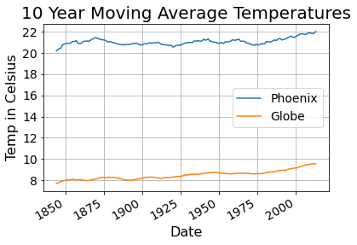

Observations from the data:

- The first obvious difference between Phoenix and the Global average temperatures is how they have a 12.5 degree difference on average. The overall average temperature of Phoenix is 21℃, while globally the overall average is 8.5℃
- Even though Phoenix is 12.5 degrees hotter than the global average, it’s clear that Phoenix followed the Global rolling average temperature rising trend in about 2 degrees over the last 180 years. The 10 year average of both Global and Phoenix between 1835 and 1845 is 7.6℃ and 20.2℃ respectively. While the 10 year averages between 2003 – 2013 is 9.5℃ Globally and 22℃ in Phoenix
- Phoenix and Global average temperatures have both been in a steady incline since the 1970s. In the last forty years of data (1973-2013) Phoenix’s rolling average has increased by 1.3℃ while the Global rolling average increase in that time was 0.9℃.
- My takeaway from this is analysis is that close to half of the temperature increase from the last 178 years happened in the last 40 years for both areas and that Phoenix is getting hotter faster than the global average increase.

